Thyroid Nodules Work-up and Management

Resource:
Up-To-Date; www.uptodate.com

Background:
Evaluation of thyroid nodules is to exclude thyroid cancer which is 4% - 6.5% of the case. Non-palpable nodules have the same risk of malignancy and palpable nodules.

Higher likelihood of Cancer:
- Children
- Adults less than 30 years or over 60 years old
- History of head and neck irradiation
- History of total body irradiation for bone marrow transplantation
- Family history of thyroid cancer
- History of rapid growth of a neck mass
- Fixed hard mass, obstructive symptoms, cervical lymphadenopathy or vocal cord paralysis

Work-up: serum TSH and ultrasound
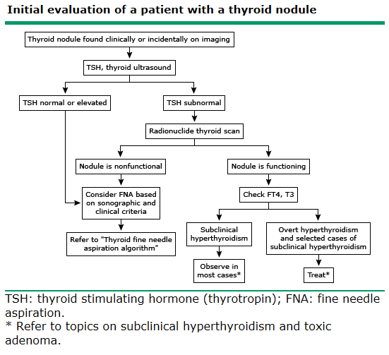

- Ultrasound features
Increase in risk of CA | Low risk of CA
Hypoechoic | Hyperechoic
Microcalcifications | Large, coarse calcifications (except for medullary CA)
“twinkling” on B-flow imaging | Peripheral vascularity
Central vascularity | Resembles puff or Napoleon pastry
Incomplete halo | Spongiform appearance
Nodule is taller than wide | Comet-tail shadowing
Documented enlargement of a nodule

- Recommendation for FNA
Ultrasound Findings and Clinical Features | Nodule Size | Recommendation
- High risk history
- Nodule with suspicious ultrasound features | > 5 mm | A
- Nodules without suspicious ultrasound features | > 5 mm | I
- Abnormal cervical lymph nodes | all | A
- Microcalcifications present in nodule | > 1 cm | B
- Solid nodule
- And hypoechoic | > 1 cm | B
- And iso- or hyperechoic | > 1 to 1.5 cm | C
- Mixed cystic-solid nodule
- With any suspicious ultrasound features | > 1.5 to 2.0 cm | B
- Without suspicious ultrasound features | > 2.0 cm | C
- Spongiform nodule | > 2.0 cm | C
- Purely cystic nodule | Not recommended

- Causes of Thyroid Nodules:
Benign | Malignant
Multinodular goiter | Papillary CA
Hashimoto’s thyroiditis | Follicular CA
Cysts: colloid, simple or hemorrhagic | - Minimally or widely invasive
Follicular adenomas | - Oxphilic (Hurtle-cell) type
- Macrofollicular adenomas | Medullary CA
- Microfollicular or cellular adenomas | Anaplastic CA
Hurtle cell (oxyphil-cell) adenomas | Primary thyroid lymphoma
- Macro- or microfollicular patterns | Metastatic carcinoma (breast, renal cell, others)

- Other work-up
  - Calcitonin- not recommended as routine
  - Anti-thyroid peroxidase (TPO) antibodies and thyroglobin- not recommended as routine
Management: 