Osteoporosis Screening, Work-up and Management

Resource:
Up-To-Date; www.uptodate.com
American Association of Clinical Endocrinologists (AACE); www.aace.org

- Background
More than 10 million American have osteoporosis and more than 34 million with low bone mass. 80% are women and most are postmenopausal. At age 60, 50% of white women have either osteopenia or osteoporosis.

Menopause-related bone loss begins 3-5 years before the last menstrual period and continues for 3-5 years afterward at a rate of 1% to 2% per year.

- At Risk for Osteoporosis
Primary Osteoporosis | Secondary Osteoporosis
Postmenopausal women | Hypogonadism
High risk population | Premature menopause
- Previous fracture | Diabetes
- Long-term glucocorticoid therapy | Malabsorption
- Low body weight (BMI < 20kg/m²) | Chronic liver disease
- Family history of hip fracture | Inflammatory bowel disease
- Cigarette smoking | Hyperparathyroidism
- Excessive alcohol intake (3+ daily) | Drugs
- Rheumatoid Arthritis | - Warfarin
- Early menopause | - Lithium
 | - Antiepileptic
 | AIDS/HIV
 | COPD
 | Renal Insufficiency/ Failure
 | Thalassemia

- Work-up
- Medical history and physical exam
  - Assess risk factors
  - Exam for height loss or kyphosis
  - Assess risk of falling
  - Laboratory (suspicious for secondary causes): CBC, CMP, iPTH, Vitamin D, TSH, free T4, Alkaline Phosphatase, 24 hour urine calcium/creatinine, and SPEP

- DEXA scan to be considered for the following population
  - Willing to take pharmacological treatment if found low
  - All women 65 years or older
  - Younger postmenopausal women
    - With history of fractures without trauma
    - Starting or taking long-term glucocorticoid therapy (>3 months)
    - With documented osteopenia
    - High risk patients (see above)
- Definition
WHO Criteria for Osteopenia and Osteoporosis
Category | T-score
Normal | -1.0 or above
Osteopenia | Between -1.0 to -2.5
Osteoporosis | -2.5 or below

- Fall Risk Assessment
FRAX Score
- Estimate the 10-year probability of hip fracture or major osteoporotic fractures for an untreated patient using femoral neck BMD
- Use country specific fracture and mortality data
- Recommend drug therapy when 10-year probability of major osteoporotic fracture exceeds 20%
- Website: www.shef.ac.uk/FRAX

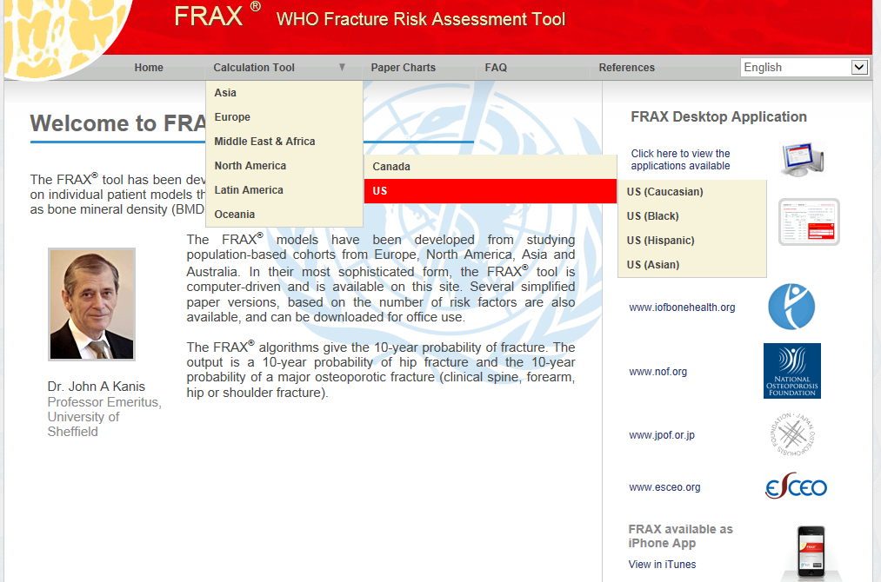

- Management
- Lifestyle changes
  - Recommended Calcium with 700-800 IU/d Vitamin D
Age | Sex | Daily Allowance (mg/d)
19-50 years | M,F | 1,000
51-70 years | M | 1,000
51-70 years | F | 1,200
71+ years | M,F | 1,200

  - Regular weight-bearing exercises
    - 30-40 minutes of walking
    - Back and posture exercises
    - Strength training
  - Avoid use of cigarettes
  - Limit alcohol consumption
  - Fall preventions
    - Anchor rugs
    - Minimize clutter
    - Remove loose wires
    - Install handrails

- Pharmaceutical
  - Recommended for post-menopausal women
  - NOT recommended for premenopausal women with low bone mass only without fractures or secondary causes
  - Need to take cost and adherence into consideration
  - First line therapy
    - Alendronate (Fosamax)
    - Risedronate (Actonel)
    - Zoledronic acid (Reclast)
    - Denosumab (Prolia)
  - Second line therapy
    - Ibandronate (Boniva)
    - Raloxifene (Evista)
  - Third line therapy
    - Raloxifene (Evista)
    - Calcitonin (Miacalcin, Fortical)
  - Teriparatide (Forteo) recommended for patients with very high fracture risk or in which bisphosphonate therapy has been ineffective- NOT recommended for patients with risk for osteosarcoma
  - See Table 1 for dosing recommendations

Table 1: Dosing Recommendations
 | Postmenopausal  osteoporosis | Glucocorticoid-induced  osteoporosis | Risk Reduction |  | Cost*  per year
First Line Drug | Treatment | Treatment | Vertebral | Hip
Alendronate# (Fosamax) in liquid and tablet forms | 10 mg PO daily or  70 mg PO weekly or  70 mg+Vit D PO weekly | 5 mg PO daily or  10 mg PO daily | Yes | Yes | $500-$800
Risedronate  (Actonel, Atelvia) | 5 mg PO daily or  35 mg PO weekly or  150 mg PO monthly or | 5 mg PO daily | Yes | Yes | $2,400
Zoledronic acid (Reclast) | 5 mg IV yearly | 5 mg IV yearly | Yes | Yes | $1,000
Denosumab (Prolia) | 60 mg SQ every 6 months |  | Yes | Yes | $2,000
Second Line Drug | Treatment | Treatment | Vertebral | Hip
Ibandronate (Boniva) | 150 mg PO monthly or  3 mg IV every 3 months |  | Yes | No effect demonstrated | $1,600  $2,200
Raloxifene (Evista) | 60 mg PO daily |  | Yes | No effect demonstrated | $2,800
Third Line Drug | Treatment | Treatment | Vertebral | Hip
Raloxifene (Evista) | 60 mg PO daily |  | Yes | No effect demonstrated | $2,800
Calcitonin (Miacalcin, Fortical) | 200 IU intranasal qd or  100 IU SQ qod |  | Yes | No effect demonstrated | $1,200  $3,700
Last Choice Drug | Treatment | Treatment | Vertebral | Hip
Teriparatide (Forteo) | 20 mcg SQ daily | 20 mcg SQ daily | Yes | No effect demonstrated | $15,000
* Cost based on average wholesale price from Redbook, 2014
# Drug cost could be less expensive through larger chain stores i.e. Target, Walmart, Costco, etc.

- Follow-up
  - Repeat DEXA scan
T-score | Frequency
-2.00 to -2.49 | Every 2 years
-1.50 to -1.99 | Every 3-5 years
-1.01 to -1.49 | Every 10-15 years

  - Changing Pharmaceuticals
    - DO NOT assume that patient is not responding to medication. Poor adherence to drug regimen is common for poor response to medication
    - GI complaints are the most common for bisphosphonates. Recommendation is to discontinue until the symptoms are resolved and to rechallenge with the same or different bisphosphonate.

  - Drug Holiday
    - No consensus on how long to continue bisphosphonate
    - Stop therapy after 3-5 years of therapy is reasonable for some women
      - Stable BMD
      - No previous vertebral fractures
      - Low risk for fracture
    - Alendronate or risedronate after 5 years
    - Zoledronic acid after 3 years
    - Restart of bisphosphonates
      - 5% bone loss on 2 DEXA scans 2 years apart

