Depression Screening, Work-up and Management

Resource:
Up-To-Date; www.uptodate.com

Background:
Depression is the most common mental health condition seen in primary care. 2/3 of primary care patients with depression present with somatic symptoms: headaches, back problems, and/or chronic pains.

Definition:
Depressive Syndrome- Major Depression | Persistent Depressive Disorder (Dysthymia)
5 + symptoms, present most of the day for at least 2 weeks | Depressive symptoms for most days for at least 2 years
Depressed mood | Decreases or increase appetite
Loss of interest or pleasure in most or all activities | Insomnia or hypersomnia
Insomnia or hypersomnia | Low energy
Change in weight or appetite | Poor self-esteem
Psychomotor retardation or agitation | Poor concentration
Low energy | Hopelessness
Poor concentration
Thoughts of worthlessness or guilt
Recurrent thoughts about death or suicide

Screening:
USPSTF recommends screening of patients during routine visits and with clinical red flags for depression: insomnia, fatigue, chronic pain, recent life changes or stressors, fair or poor self-rated health, unexplained physical symptoms.

Screening Tools- Both are available in NextGen
- PHQ-2: brief and less accurate (sensitivity 83%, specificity 90%)

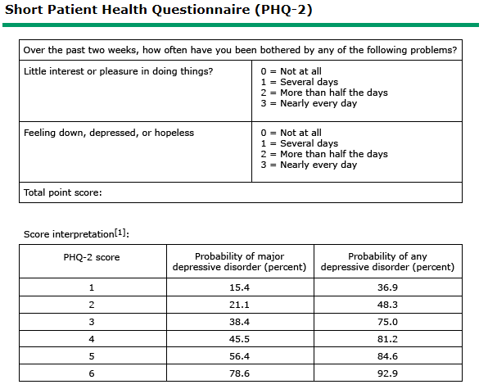
A single YES or score > 3 indicates possible depression.
- PHQ-9: more accurate (sensitivity 88%, specificity 88%)

PHQ-9 Depression Questionnaire
Questions | Response
Over the last 2 weeks, how often have you been bothered by any of the following problems? | Not at all | Several days | More than half the day | Nearly every day
- Little interest or pleasure in doing things | 0 | 1 | 2 | 3
- Felling down, depressed, or hopeless | 0 | 1 | 2 | 3
- Trouble falling or staying asleep or sleeping too much | 0 | 1 | 2 | 3
- Felling tired or having little energy | 0 | 1 | 2 | 3
- Poor energy or overeating | 0 | 1 | 2 | 3
- Feeling bad about yourself, or that you are a failure, or have let you or your family down | 0 | 1 | 2 | 3
- Trouble concentrating on things, such as reading the newspaper or watching television | 0 | 1 | 2 | 3
- Moving or speaking so slowly that other people could have noticed? Or the opposite, being so fidgety or restless that you have been moving around a lot more than usual | 0 | 1 | 2 | 3
- Thoughts that you would be better off dead or of hurting yourself in some way | 0 | 1 | 2 | 3
Total- A score > 10: likely major depression

PHQ-9 Depression Score Ranges
Score | Rating
5-9 | Mild
10-14 | Moderate
15-19 | Moderately severe
> 20 | severe

Management:
Recurrence of depression is very common. Greater than 40% of patients will have another episode within 2 years and 75% within 5 years. The goal for treating depression is symptom remission and restoring baseline functioning.

The treatment plan will vary depending on the severity of the patient. When choosing a drug regimen, please take the following into consideration…
- Patient’s response to prior antidepressants
- Safety
- Side effects
- Comorbidity
- Concurrent medications and potential drug-drug interactions
- Family history of response to antidepressants
- Ease of use
- Patient preference
- Cost

Severity | Pharmaceutical |  | Psychotherapy
 | 1st line | Alternatives | 1st line | Alternatives
Mild to moderate major depression | - SSRIs | - Serotonin-norepinephrine reuptake inhibitors  - Atypical antidepressants  - Serotonin modulators | - Cognitive behavior  - Interpersonal psychotherapy | - Family  - Couples  - Psychodynamic  - Supportive
Severe major depression | - SSRIs  - Serotonin-norepinephrine reuptake inhibitors | - Mirtazapine  - Tricyclic antidepressants | - Cognitive behavior  - Interpersonal psychotherapy | - Family  - Couples  - Psychodynamic  - Supportive
Persistent Depressive disorder | - Antidepressants |  | - Cognitive behavior  - Interpersonal psychotherapy | - Family  - Couples  - Psychodynamic  - Supportive

Electroconvulsive therapy (ECT) could be considered as an initial treatment option for patients with severe suicidal tendencies or malnutrition secondary to food refusal.

See separate handout for a list of medication with dosing recommendations and side effects.

